MLOps (ML Operations) 是一種結合了 機器學習（ML）和 運維操作（DevOps）的方法，用於自動化和管理機器學習模型的開發、部署、監控和維護的整個生命周期。MLOps 旨在提高機器學習模型在生產環境中的可靠性、可擴展性和效率，促進數據科學家、機器學習工程師與運維團隊之間的協作。

**MLOps 的核心概念：**

1. 自動化模型訓練與部署：

* MLOps 強調模型的自動化訓練、測試和部署流程，確保模型能夠迅速從開發階段過渡到生產環境中，並且能夠**不斷迭代和改進**。

2. 持續集成與持續部署（CI/CD）：

* MLOps 中應用 DevOps 的 CI/CD 概念，實現模型從**開發**到**部署**的**持續集成**與**持續交付**。當模型或數據發生變更時，自動化流程可以幫助模型重新訓練並部署至生產環境，保證系統的靈活性和敏捷性。

3. 模型監控與性能管理：

* MLOps 包括對機器學習模型在生產環境中的**持續監控**，跟蹤模型的性能和準確性，及時識別模型漂移（Model Drift）或異常行為，並進行相應的調整或重新訓練。

4. 版本控制與可追溯性：

* MLOps 中涉及模型和數據的版本控制，確保模型在不同階段的變更可追溯。這包括對模型的超參數、訓練數據集和模型結果進行版本管理，以確保模型的可復現性和可追蹤性。

5. 協作與組織協調：

* MLOps 鼓勵數據科學家、機器學習工程師、開發人員和運維團隊之間的協作，確保機器學習項目從研發到生產的順利過渡。

**MLOps 的重要步驟：**

1. 數據收集與預處理：自動化收集和準備數據的管道，確保數據質量。
2. 模型訓練與評估：建立自動化流程來訓練、測試和評估模型，確保準確性和穩定性。
3. 模型部署：使用持續集成（CI）和持續部署（CD）將模型自動部署到生產環境中，並定期進行更新。
4. 模型監控與管理：實時監控模型的性能和行為，確保模型在生產環境中的有效性。
5. 模型更新與重新訓練：當模型性能下降或數據分布變化時，自動進行重新訓練和更新。

**MLOps 的好處：**

* 加速開發與部署：通過自動化機器學習工作流，縮短模型從研發到生產的時間。
* 提高模型穩定性和可擴展性：通過持續監控和優化，確保模型在生產環境中的穩定性。
* 高效的模型管理：有效管理模型版本、數據和配置，保證模型的可復現性。
* 增強團隊協作：促進數據科學、運維和開發團隊之間的合作，提高項目的成功率。

**實際應用場景：**

* 自動駕駛車輛：在自動駕駛系統中，MLOps 可以幫助模型的快速迭代和部署，並實時監控模型性能，確保車輛在不同場景下的安全性。
* 電子商務推薦系統：MLOps 幫助管理和部署推薦模型，並根據用戶行為變化對模型進行持續更新和優化。
* 醫療診斷系統：在醫療領域，MLOps 可幫助管理診斷模型，並確保模型在不同患者和環境下的穩定性和準確性。

**總結：**

MLOps 是將機器學習模型大規模部署並持續優化的最佳實踐方法。它通過自動化流程、持續集成和部署，確保機器學習模型能夠高效、安全、可擴展地運行在生產環境中。

**MLOps** 是一個快速發展的領域，幫助企業在生產環境中更高效地部署和管理機器學習模型。儘管 MLOps 提供了許多好處，但仍然面臨一些**挑戰**，特別是在實際應用中。以下是當前 MLOps 領域的幾個主要挑戰：

1. 數據質量與管理

* 挑戰： 機器學習模型的準確性和性能高度依賴於**數據質量**。隨著數據的規模、來源和類型越來越多樣化，確保數據的完整性、一致性和及時性變得越來越困難。
* 解釋： 不同數據源之間的數據標準不統一，可能導致數據清理和預處理工作量過大。此外，當數據出現異常或質量下降時，模型性能會下降，從而影響業務結果。
* 解決方案： 需要建立完善的**數據治理**和**監控系統**，確保數據在整個管道中的質量。

2. 模型監控與漂移

* 挑戰： 在生產環境中，模型的性能可能會隨著時間推移而下降，這通常是由於數據漂移（**Data Drift**）或概念漂移（**Concept Drift**）造成的，導致模型的預測能力變差。
* 解釋： **數據漂移**是指**數據分佈**隨時間的**變化**，**概念漂移**則是指模型所處的業務環境或**市場**條件發生**變化**，這些都會導致模型無法像最初一樣準確地做出預測。
* 解決方案： 需要建立模型監控機制，持續監控模型的性能表現，並在模型性能下降時觸發重新訓練或調整。

3. 持續集成與部署（CI/CD）

* 挑戰： MLOps 涉及到模型的持續集成與持續部署（CI/CD），但與傳統軟件開發不同，機器學習模型在生產過程中需要處理**數據版本**、**模型版本**、**模型依賴項**和**環境**等因素，這使得機器學習的 CI/CD 流程更為複雜。
* 解釋： 不僅是軟件代碼需要版本控制，**數據**、**超參數**、**模型配置**等多個方面也需要**進行版本管理**。此外，模型的訓練和部署流程需要與軟件開發流暢集成，這增加了自動化和協作的難度。
* 解決方案： 需要定制化的 CI/CD 工具和框架來處理機器學習特有的挑戰，例如數據和模型的版本管理、超參數調整等。

4. 跨團隊協作困難

* 挑戰： MLOps 涉及多個職能團隊的合作，包括數據科學家、機器學習工程師、軟件開發團隊和運維團隊。不同團隊之間可能存在溝通不暢、工具和方法論不一致的問題。
* 解釋： 數據科學家可能使用 Python 或 R 進行建模，而開發人員和運維團隊則偏好用其他工具或語言。這種技術棧和工作流程的差異會導致模型從開發到生產的過渡變得困難和低效。
* 解決方案： 建立統一的工作流和工具鏈，促進不同團隊之間的合作，並鼓勵跨職能的溝通和協調。

5. 模型解釋性與透明性

* 挑戰： 當前許多機器學習模型（如深度學習模型）是「黑盒」模型，解釋其內部決策過程較為困難。對於某些應用場景（如醫療、金融）來說，模型的透明性和解釋性至關重要，尤其是在模型對用戶或業務產生重大影響時。
* 解釋： 在需要高可解釋性的領域（如風險評估、信用評分等），如果模型做出了錯誤的預測，難以解釋其決策過程，可能會導致業務問題甚至法律風險。
* 解決方案： 使用更具解釋性的模型（如決策樹）或引入模型解釋技術（如 LIME、SHAP）來增加模型透明性，幫助業務決策者理解模型的輸出結果。

6. **模型管理**與**版本控制**

* 挑戰： 在 MLOps 中，需要對大量的模型進行有效管理，包括模型的版本控制、訓練數據集的版本管理以及超參數調整的跟蹤。隨著模型的數量和復雜度增加，管理這些模型的難度也會顯著增加。
* 解釋： 訓練數據的變化、超參數調整或代碼的更新都可能導致模型性能發生改變，因此需要跟蹤每次模型訓練的詳細信息，以便日後復現和調整。
* 解決方案： 使用**模型管理工具**（如 **MLflow**、**Kubeflow**）來跟蹤和管理模型的所有變更，確保每個模型訓練階段的可追溯性和可復現性。

7. **合規**與**安全性**

* 挑戰： 在許多行業中，機器學習應用需要符合嚴格的數據隱私和安全規範（如 GDPR）。MLOps 不僅需要處理技術挑戰，還需要確保模型的合規性和數據的安全性。
* 解釋： 使用敏感數據進行機器學習時，如何保護數據隱私和防止數據洩漏至關重要。此外，模型部署後需要防範潛在的安全威脅，如對抗性攻擊等。
* 解決方案： 引入數據匿名化、差分隱私等技術，並建立健全的安全機制來保護模型和數據。

**總結：**

MLOps 面臨的挑戰主要涉及數據質量、模型管理、跨團隊協作以及合規與安全等多個方面。要成功應用 MLOps，企業需要構建自動化、高效且可持續的流程，並解決這些挑戰，以便讓機器學習模型在生產環境中穩定運行並產生預期效益。

MLOps 是機器學習（ML）運營領域的一個**迅速發展**的分支，隨著技術的進步和應用場景的擴大，MLOps 未來的發展趨勢將越來越明顯。以下是 MLOps 的幾個關鍵未來趨勢與發展方向：

1. 全面自動化與智能化

* 趨勢：未來，MLOps 將會朝著更高層次的**自動化**和**智能化**發展，通過人工智慧和自動化工具實現端到端的機器學習工作流程管理。這將包括從數據處理、模型訓練、測試、部署到監控的全過程自動化。
* 具體應用：例如，利用**自動化管道工具**（如 Kubeflow、MLflow 等）來自動化模型訓練與部署，並**結合 AI 驅動**的優化技術，進行超參數自動調整（**AutoML**）和自動化模型選擇，讓系統能夠自主選擇最佳算法和配置，並實現模型的持續改進。

2. AI與ML模型的持續監控與治理

* 趨勢：隨著 AI 和 ML 模型越來越廣泛應用，對模型的**治理**和**持續監控**將成為關鍵焦點。未來，MLOps 會進一步加強對模型的監控和管理，特別是針對模型漂移（Model Drift）、數據偏差和公平性問題。
* 具體應用：自動化的監控系統將實時監控生產環境中的模型性能，並檢測數據漂移和模型漂移，當模型表現下降時自動觸發重新訓練或模型更新。此外，這些系統將確保模型結果符合公平性和透明性要求，以避免數據偏見。

3. 模型解釋性與可解釋 AI（Explainable AI, XAI）

* 趨勢：隨著 AI 在醫療、金融等高風險行業中的應用增長，對模型解釋性的需求會越來越高。MLOps 未來將更多地與 可解釋 AI（XAI） 相結合，幫助企業理解模型的決策過程，特別是在涉及敏感或合規領域時。
* 具體應用：通過結合可解釋性技術（如 **LIME**、**SHAP**），MLOps 平台將提供模型預測結果的可解釋性，讓使用者能夠追溯模型如何得出結論，並評估模型的風險和合規性。此外，這些技術將有助於解釋黑盒模型（如深度學習模型）的決策邏輯。

4. 跨多雲與邊緣計算的擴展

* 趨勢：隨著企業對於多雲環境和邊緣計算的需求增長，MLOps 將適應這些環境並進行更靈活的部署。模型將不僅運行在單一雲端，而是能夠同時在多個雲平台或邊緣設備上進行訓練和推理。
* 具體應用：未來的 MLOps 工具將能夠在多個雲服務供應商（如 AWS、GCP、Azure）之間無縫運行，並且能夠優化雲端資源的利用。隨著物聯網（IoT）和邊緣設備的普及，MLOps 也將支持邊緣推理，讓模型在接近數據源的地方執行，從而提高響應速度和降低延遲。

5. 持續集成、持續部署與持續監控（CI/CD/CM）進一步融合

* 趨勢：MLOps 將進一步加強 持續集成（CI）、持續部署（CD） 和 持續監控（CM） 的融合，讓模型在開發、部署和運維之間實現更快、更高效的迭代。
* 具體應用：未來的 MLOps 流程將能夠實現模型的自動化迭代，當新數據到來時，系統能夠自動更新模型並進行性能監控，確保模型始終處於最佳狀態。這種完全自動化的 CI/CD/CM 流程將使模型能夠持續改進並保持精確度。

6. 更強的模型版本控制與治理框架

* 趨勢：隨著越來越多的模型進入生產環境，對模型版本控制和治理的需求將變得更加迫切。MLOps 的未來將包括更完善的模型版本管理和治理框架，以確保模型的可追溯性和合規性。
* 具體應用：模型版本管理工具將能夠跟蹤模型訓練時使用的數據、參數和算法，並提供每次模型更新的完整歷史記錄。此外，MLOps 系統將強化模型的合規性審查，確保模型符合行業規範（如 GDPR 或 HIPAA）。

7. 隱私保護技術的整合

* 趨勢：未來的 MLOps 平台將更多地整合 隱私保護技術，如差分隱私（Differential Privacy） 和 聯邦學習（Federated Learning），以便在訓練模型的同時保護用戶數據的隱私。
* 具體應用：差分隱私技術將在數據處理過程中確保用戶個人信息不會被暴露，而聯邦學習允許模型在不共享原始數據的前提下進行分佈式訓練。這些技術的應用將使企業能夠在保護數據隱私的同時，仍然能夠從海量數據中獲得洞察。

8. AutoML 與 AutoMLOps 的興起

* 趨勢：自動化機器學習（AutoML）將進一步成熟，並與 MLOps 深度整合，最終發展為 AutoMLOps，即從數據收集到模型部署的全過程完全自動化。
* 具體應用：AutoML 工具將能夠自動進行特徵工程、模型選擇、超參數調優和性能測試，並且與 MLOps 結合後，這些模型將被自動部署到生產環境中，實現端到端的全自動化工作流。這將降低機器學習的門檻，使更多企業能夠使用 AI 來解決業務問題。

9. 民主化的機器學習與低代碼/無代碼平台

* 趨勢：未來，隨著 MLOps 工具變得更加易於使用，將有更多的「**低代碼**」或「**無代碼**」平台崛起，使非技術人員也能參與機器學習模型的開發和部署。
* 具體應用：這些平台將通過**可視化工具**、模板和自動化功能，讓業務分析師、數據專家和產品經理也能夠進行機器學習模型的開發和部署，無需深入了解複雜的算法和編程。

**總結：**

MLOps 的未來發展將圍繞自動化、智能化、多雲環境、隱私保護和模型治理等多個方面展開。隨著技術的不斷進步，MLOps 將進一步推動機器學習的應用普及，讓企業能夠更加靈活高效地管理和部署機器學習模型，實現更大規模的 AI 應用。

**ML Lifecycle**

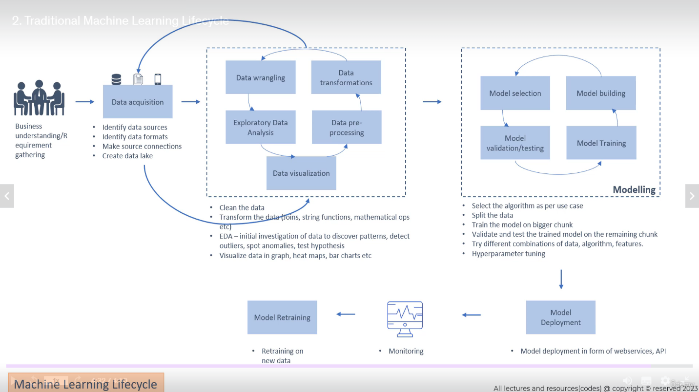

Traditional machine learning lifecycle, illustrating the stages involved in building and deploying a machine learning model. Here’s how you can describe the lifecycle with stakeholder involvement:

**1. Business Understanding/Requirement Gathering (Stakeholder Involvement)**

* **Involvement of stakeholders**: Stakeholders, including **business leaders** and **data scientists**, define the business problem, clarify the objectives, and gather specific requirements. This stage ensures alignment between the business goals and the technical implementation.

**2. Data Acquisition**

* **Activities**: Identify data sources, formats, and make connections to data systems or create data lakes.
* **Involvement of stakeholders**: **Data engineers** and **data scientists** collaborate to collect and make data accessible.

**3. Data Preparation (Data Wrangling, Transformation, Pre-processing, and Visualization)**

* **Activities**: Data cleaning, transformations, exploratory data analysis (EDA), and data visualization (by using Jupyter Notebook).
* **Involvement of stakeholders**: **Data scientists** and **engineers** work together to ensure that data is in the right format and ready for analysis. Stakeholders may be consulted for domain-specific insights during EDA.

**4. Modelling**

* **Activities**: Selecting the appropriate model, building, training, validating/testing, and hyperparameter tuning.
* **Involvement of stakeholders**: **Data scientists** and **machine learning engineers** (using Python)are responsible for this stage, while stakeholders provide feedback on model performance, guiding necessary adjustments.

**5. Model Deployment**

* **Activities**: The trained model is deployed in the form of web services or APIs.
* **Involvement of stakeholders**: **IT teams** and stakeholders involved in operations or product development oversee the deployment. Product managers ensure the deployment aligns with business goals.

**6. Model Retraining & Monitoring**

* **Activities**: Monitor model performance and retrain on new data as needed.
* **Involvement of stakeholders**: Monitoring is done by **data scientists** and **DevOps teams**. **Business** stakeholders provide input on the model's impact, ensuring continuous alignment with business objectives.

This lifecycle highlights how stakeholder engagement is essential in ensuring that the technical work aligns with the business requirements, from data acquisition to model deployment and monitoring.

MLOps (Machine Learning Operations) is a set of **practices** and **tools** that aim to **automate** and **streamline** the machine learning (ML) **lifecycle**. It extends DevOps principles (from software development) to machine learning, ensuring that ML models are **developed**, **deployed**, **monitored**, and **maintained** efficiently in production environments. MLOps addresses the challenges unique to machine learning, such as model training, data versioning, model monitoring, and retraining, which are critical in maintaining the performance and relevance of deployed models.

**Relation of MLOps to the ML Lifecycle:**

1. **Data Acquisition and Preprocessing**
   * **MLOps tools** automate data ingestion, data versioning, and the preprocessing pipelines.
   * **Data validation** and quality checks can be built into the MLOps pipeline to ensure the data used for model training is consistent and accurate over time.
2. **Model Training and Selection**
   * **Continuous integration** of machine learning models is a key concept in MLOps, allowing models to be retrained automatically when new data is available.
   * **Automated training pipelines** are set up, which include feature engineering, model selection, and hyperparameter tuning, ensuring reproducibility across different environments.
3. **Model Deployment**
   * **MLOps facilitates automated model deployment**, whether it’s deploying models as APIs, microservices, or integrating them into existing business systems.
   * **Version control for models** ensures the right model version is deployed and can be easily rolled back if needed.
4. **Monitoring and Feedback**
   * **Model performance monitoring** is critical in MLOps. It continuously monitors for model drift, performance degradation, and changes in data distributions.
   * **Alert systems** notify stakeholders when a model's performance falls below a threshold, and retraining processes can be triggered automatically.
5. **Model Retraining**
   * **Automated retraining pipelines** in MLOps ensure that models are retrained when new, relevant data becomes available or when the performance of the deployed model declines.
   * **CI/CD (Continuous Integration/Continuous Deployment)** for machine learning models supports the continuous improvement of models without manual intervention.
6. **Collaboration & Governance**
   * MLOps provides a framework for **collaboration** between data scientists, ML engineers, and operations teams, ensuring that machine learning models are well-documented, traceable, and meet compliance standards.
   * **Governance** tools are embedded to track datasets, features, models, and metrics, ensuring transparency and accountability.

**Key Features of MLOps:**

* **Automation**: From data preprocessing to deployment, automation is central to reducing the time it takes to move from development to production.
* **Reproducibility**: MLOps ensures that models and experiments can be easily reproduced in different environments, with clear version control for both data and code.
* **Scalability**: MLOps frameworks support scaling ML pipelines, model training, and deployment for large-scale applications.
* **Monitoring**: Continuous monitoring of model performance in production environments is critical for detecting issues like model drift or degraded accuracy.

**Tools in MLOps:**

* **KubeFlow, MLflow, TensorFlow Extended (TFX)**: For building end-to-end ML pipelines.
* **Docker, Kubernetes**: For containerization and orchestration, enabling the scaling of ML models.
* **Airflow**: For orchestrating workflows, often used in the context of data pipelines and model retraining.
* **Seldon, BentoML**: For model deployment and serving.

**Tool Stack Recommendations by Stage:**

* **Data Acquisition & Preprocessing**: Apache **Airflow**, **Kubeflow** **Pipelines**, Great Expectations, DVC, Delta Lake.
* **Model Training & Selection**: **MLflow**, **Kubeflow**, Azure ML, TFX, SageMaker.
* **Model Deployment**: Seldon Core, TensorFlow Serving, BentoML, **Docker + Kubernetes**.
* **Monitoring & Feedback**: **Prometheus + Grafana**, Evidently AI, Fiddler AI, Arize AI, **WhyLabs**.
* **Model Retraining**: **Kubeflow**, **MLflow**, **Airflow**, Azure ML, DataRobot.
* **Collaboration & Governance**: **MLflow**, **Weights & Biases**, DVC, **GitHub**, Comet ML, Azure ML.

**MLOps vs. Traditional ML Lifecycle**

In traditional machine learning, a model may be built, trained, and deployed, but managing the entire lifecycle beyond initial deployment is often manual and inconsistent. MLOps provides a systematic, automated, and scalable framework to handle the end-to-end machine learning lifecycle, ensuring models remain functional and valuable in production environments over time.

In summary, MLOps is crucial to operationalizing the ML lifecycle by automating and standardizing processes, making it easier to build, deploy, monitor, and maintain models in production settings.

In MLOps, monitoring machine learning models in production is crucial for ensuring they continue to perform as expected, detecting performance degradation, and responding to issues like data drift or model bias. Various tools are available to help monitor different aspects of the ML lifecycle. Here are key categories of monitoring tools and examples for each:

**1. Model Performance Monitoring Tools**

These tools track the performance of models over time, including metrics like accuracy, precision, recall, and more. They help ensure models are still producing reliable results in production.

* **WhyLabs**: Focuses on monitoring models in production, detecting data drift, and performance degradation, while offering alerts and anomaly detection.
* **Arize AI**: Provides model performance monitoring, drift detection, and root cause analysis. It offers visualizations to understand model behavior in production environments.
* **Fiddler AI**: Monitors models for performance issues, fairness, and explainability. It provides alerts for performance degradation, drift, and bias.
* **Seldon Core**: Offers model monitoring and explanation features within the context of deployment in Kubernetes, using Prometheus and Grafana for visualizing key metrics.
* **Evidently AI**: An open-source tool for monitoring and analyzing model performance and detecting issues like concept and data drift. It generates reports to track model behavior over time.

**2. Data Drift and Concept Drift Detection Tools**

Data drift occurs when the distribution of the incoming data changes compared to the data the model was trained on. Concept drift occurs when the underlying relationships between the input and output variables change.

* **Evidently AI**: Provides tools to monitor and detect data and concept drift, and it can create dashboards to track changes in the input data over time.
* **Amazon SageMaker Model Monitor**: A fully managed service from AWS that monitors models deployed in SageMaker for data and concept drift, as well as model quality and bias.
* **MLflow**: Although primarily known as a model management tool, MLflow can track and monitor the performance of models, allowing you to detect drift by tracking performance metrics over time.
* **WhyLabs:** A good tool for **data drift** and **concept drift** detection in machine learning models, particularly for production environments. It is designed to monitor models in production for changes in data patterns and model performance over time.

**3. Real-Time Model Monitoring Tools**

Real-time monitoring tools capture live data from deployed models and provide insights on a continuous basis.

* **Prometheus + Grafana**: These are popular open-source tools for real-time monitoring. Prometheus can be used to scrape metrics from models and generate alerts, while Grafana provides visual dashboards to analyze those metrics in real time.
* **Datadog**: A cloud-scale monitoring tool that integrates with machine learning systems to provide real-time metrics, logs, and alerts. Datadog can track the health and performance of ML models in production.
* **Kibana + Elastic Stack (ELK Stack)**: Used for monitoring logs, errors, and system performance in real time. This can also track model outputs and errors during deployment.

**4. Bias and Fairness Monitoring Tools**

Tools that focus on ensuring machine learning models remain fair and unbiased, especially after deployment, by monitoring the distribution of predictions across different demographic or user groups.

* **AI Fairness 360 (AIF360)**: An open-source toolkit developed by IBM to detect and mitigate bias in machine learning models. It can be used to monitor for fairness issues post-deployment.
* **Fairlearn**: An open-source Python package developed by Microsoft for assessing and improving the fairness of machine learning models. It monitors and mitigates unfairness in classification and regression models.

**5. System and Resource Monitoring Tools**

These tools ensure that the infrastructure on which the model is deployed is running efficiently and that system-level metrics such as CPU, memory, and disk usage are within normal ranges.

* **Prometheus**: A widely used open-source system monitoring tool. When integrated with models and applications, Prometheus can monitor resource consumption (CPU, memory), model request times, and failure rates.
* **Grafana**: Works with Prometheus to visualize metrics related to system resources as well as model-specific metrics.
* **New Relic**: A cloud-based tool that provides infrastructure monitoring, application performance monitoring (APM), and real-time analytics. It can track resource consumption of deployed models and applications.

**6. ML-Specific Cloud-Based Monitoring Services**

Many cloud providers offer managed solutions to monitor machine learning models within their ecosystems.

* **Amazon SageMaker Model Monitor**: Automatically monitors models deployed in Amazon SageMaker, detecting issues like bias, drift, and data quality problems.
* **Azure Machine Learning Model Monitoring**: Provides continuous monitoring of models deployed on Azure, including data drift, model accuracy, and feedback loops.
* **Google Cloud AI Platform Prediction**: Monitors models deployed on Google’s AI Platform for model predictions and performance metrics like accuracy, precision, and recall. It integrates with Google Cloud Monitoring for system-level monitoring.

**7. Explainability and Accountability Monitoring Tools**

Tools that focus on understanding the decision-making process of machine learning models, providing insights into why a particular decision was made, which is critical in regulated industries.

* **LIME (Local Interpretable Model-agnostic Explanations)**: Provides explanations for predictions made by black-box models by generating locally interpretable models around each prediction.
* **SHAP (SHapley Additive exPlanations)**: A widely used framework for explaining machine learning models, allowing for detailed insights into feature importance and model decision-making.
* **Alibi Explain**: A toolkit for machine learning model interpretation, used in conjunction with deployment tools like Seldon Core for real-time model explainability in production.

**8. Logging Tools for Model Operations**

Logging tools are essential for capturing real-time logs of model predictions, errors, and other key activities related to models in production.

* **Logstash + Kibana (Elastic Stack)**: Useful for capturing logs related to ML models, including errors, input/output logs, and other relevant performance indicators.
* **Fluentd**: An open-source data collector that can aggregate logs from different sources, including ML systems, and send them to monitoring tools like Prometheus or ELK Stack.
* **Airflow Logs**: For ML pipelines orchestrated with Airflow, logging is built in to track pipeline execution and individual model tasks.

**Integrating Monitoring Tools into MLOps Pipelines**

In an MLOps environment, monitoring tools are typically integrated into the CI/CD pipeline to ensure automated and continuous monitoring of machine learning models. This is achieved by:

* **Logging metrics** (e.g., accuracy, precision, recall, F1 score) and metadata (e.g., model version) during model inference.
* **Alerting systems** to notify teams when performance deteriorates or anomalies (e.g., drift, bias) are detected.
* **Scheduled retraining pipelines** triggered by monitoring tools when performance thresholds are breached or new data becomes available.

In summary, monitoring tools in MLOps are diverse, focusing on different aspects such as model performance, data drift, system resources, bias, and explainability. The right combination of these tools helps maintain the reliability, fairness, and effectiveness of ML models in production.

**Activities to Productionize a Model**

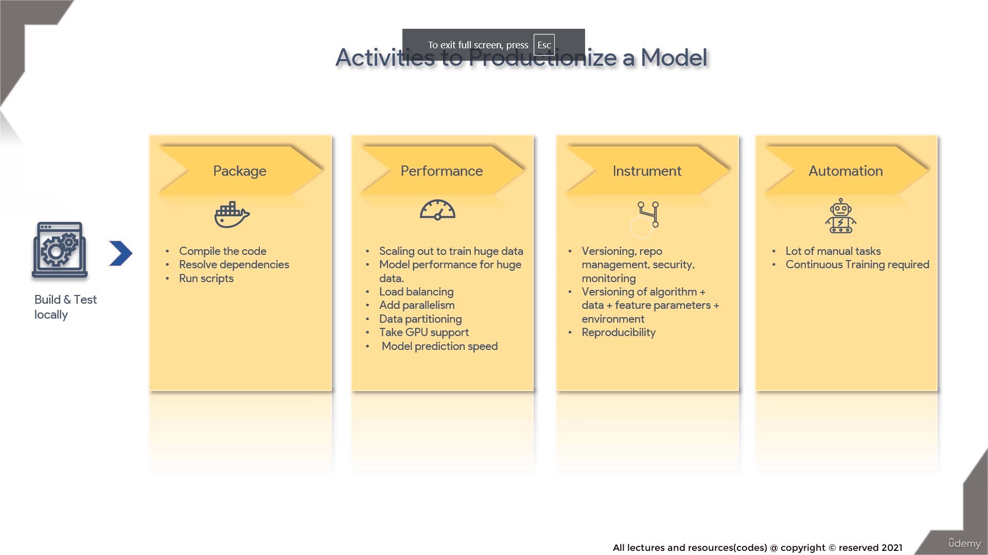

**Activities to Productionize a Model** and the key steps involved in taking a machine learning model from local development to production. Here is a breakdown of the process and its explanation:

**1. Build & Test Locally**

* Before moving to production, models are first built and tested locally. This involves:
  + Developing the model on local machines.
  + Ensuring that the model is functioning as expected by running tests with sample data.

**2. Package**

* The next step after local testing is packaging the model so it can be deployed into production environments. This includes:
  + **Compile the code**: Ensuring the model code is compiled and ready for deployment.
  + **Resolve dependencies**: Addressing and bundling all the dependencies (libraries, frameworks) the model needs to function.
  + **Run scripts**: Executing the necessary scripts to prepare the model for deployment, which could include creating Docker containers or preparing environments.

**3. Performance**

* In a production environment, performance considerations are critical, especially for models working with large datasets or needing to respond in real time. Performance activities include:
  + **Scaling out to train huge data**: Ensuring the model can handle large datasets efficiently.
  + **Model performance for huge data**: Optimizing the model for performance when processing large amounts of data.
  + **Load balancing**: Distributing model inference requests across multiple machines to ensure smooth operation and scalability.
  + **Add parallelism**: Introducing parallel processing to improve speed and efficiency in training and inference.
  + **Data partitioning**: Splitting large datasets into smaller parts for faster processing.
  + **Take GPU support**: Leveraging GPUs to accelerate model training and inference.
  + **Model prediction speed**: Ensuring that the model makes predictions quickly enough to meet production requirements.

**4. Instrument**

* Instrumentation is about setting up the necessary infrastructure for managing, monitoring, and maintaining models. This includes:
  + **Versioning, repo management, security, monitoring**: Keeping track of model versions, ensuring secure access to models, and monitoring performance in real-time.
  + **Versioning of algorithm + data + feature parameters + environment**: Managing versions not only of the model itself but also the data, features, and environment to ensure reproducibility.
  + **Reproducibility**: Ensuring that models can be re-trained or reproduced with the same results in the future by tracking all necessary artifacts.

**5. Automation**

* Many tasks involved in managing models in production can be automated to reduce manual work and maintain efficiency:
  + **Lot of manual tasks**: Highlighting the need to automate repetitive manual tasks to ensure faster deployments.
  + **Continuous Training required**: Setting up continuous training pipelines where models are retrained automatically when new data is available or performance degrades.

**Overall Process Explanation:**

This workflow emphasizes the activities involved in transitioning a machine learning model from local development into production. It covers packaging the model, ensuring it can handle large data and scaling challenges, instrumenting it for monitoring and security, and automating the processes for continuous operation. Each step ensures the model can be used efficiently, monitored, and improved in a production environment, while maintaining performance and reproducibility.

**Technical Debt for Machine Learning**

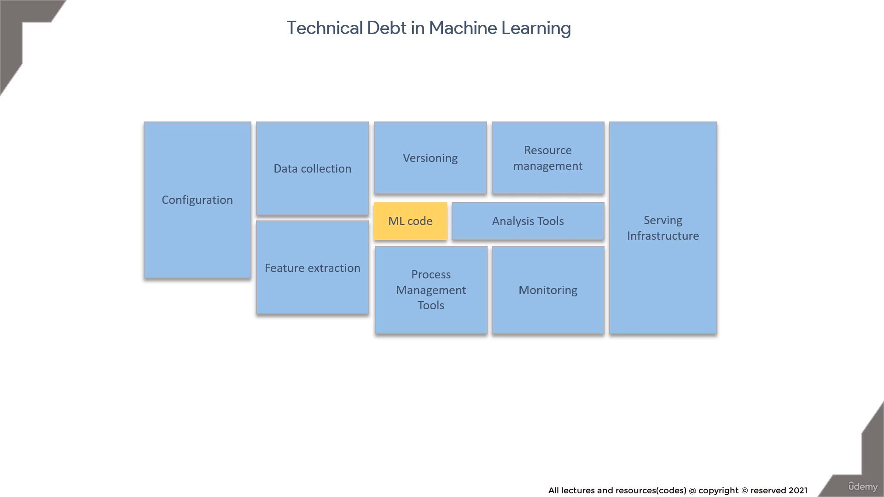

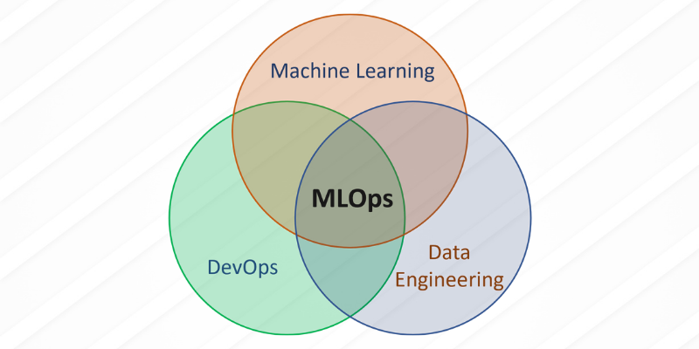

The following classification highlights which items are more aligned with **DevOps** and which are specifically relevant to **MLOps**. Keep in mind that MLOps extends DevOps principles to the full machine learning lifecycle, so there will be some overlap.

**1. Items Related to DevOps:**

These are areas where **DevOps principles**—such as automation, infrastructure management, CI/CD, and monitoring—are applicable, independent of machine learning:

* **Configuration**:
  + **DevOps**: Configuration management is crucial for setting up environments (e.g., cloud infrastructure, dependency management) consistently and reproducibly. Tools like **Terraform**, **Ansible**, and **Helm** help manage configurations.
* **Versioning**:
  + **DevOps**: In DevOps, version control is essential for managing the codebase. For machine learning, this includes not only versioning the ML code but also the infrastructure and automation scripts.
* **Resource Management**:
  + **DevOps**: Managing compute resources (e.g., CPU, memory, disk, network) is central to DevOps. In machine learning, this is particularly critical for scaling training jobs or model inference services, using **Kubernetes** or cloud infrastructure.
* **Monitoring**:
  + **DevOps**: Continuous monitoring of system performance, uptime, and failures applies directly from DevOps. Tools like **Prometheus** and **Grafana** can monitor infrastructure, model performance, and model inference services.
* **Process Management Tools**:
  + **DevOps**: Tools like **Jenkins**, **GitLab CI**, and **Circle CI** are DevOps staples for managing workflows and automating pipelines.
* **Serving Infrastructure**:
  + **DevOps**: DevOps practices focus on deploying, managing, and scaling infrastructure for running applications (e.g., web servers, APIs, etc.). This directly translates into serving machine learning models via containers, using **Docker**, **Kubernetes**, **Seldon**, or **BentoML** for model serving.

**2. Items Related to MLOps:**

These are areas where **MLOps** comes into play, specifically focusing on the additional challenges related to machine learning workflows, data management, and model lifecycle management:

* **ML Code**:
  + **MLOps**: While DevOps handles general code management, MLOps focuses on the additional complexity of managing machine learning code, including model code, algorithm design, and integration with the data pipeline.
* **Data Collection**:
  + **MLOps**: Data is the backbone of machine learning, and MLOps emphasizes automated data collection pipelines, data versioning, and preprocessing. Tools like **Apache Airflow**, **Kubeflow Pipelines**, and **DVC** manage data collection and processing workflows.
* **Feature Extraction**:
  + **MLOps**: The feature extraction process, which transforms raw data into usable input for models, is a core part of MLOps. Managing and automating feature engineering workflows ensures reproducibility and proper tracking of features used in different models. Tools like **Feature Store** and **Feast** are used to manage features across different pipelines.
* **Analysis Tools**:
  + **MLOps**: Data and model analysis tools help monitor model accuracy, performance, and fairness. Tools like **Evidently AI**, **WhyLabs**, and support continuous evaluation of models in production.

**3. Overlap between DevOps and MLOps:**

Some items fall under both **DevOps** and **MLOps**, as MLOps essentially extends DevOps practices to machine learning:

* **Versioning**:
  + **DevOps** focuses on code versioning.
  + **MLOps** extends this to model versioning, data versioning, feature versioning, and environment versioning. Tools like **MLflow**, **DVC**, or **Git** are commonly used.
* **Resource Management**:
  + **DevOps** handles general compute resources, but **MLOps** optimizes the use of specialized resources like GPUs and TPUs for model training and inference.
* **Monitoring**:
  + **DevOps** focuses on monitoring system performance.
  + **MLOps** extends monitoring to model performance, drift detection (data drift and concept drift), and model accuracy in production using tools like **WhyLabs**, **Evidently AI**, or **Prometheus** with custom metrics.
* **Serving Infrastructure**:
  + **DevOps** covers infrastructure for serving applications, while **MLOps** manages the serving of machine learning models (model as a service), using tools like **Seldon Core**, **TensorFlow Serving**, and **BentoML**.

**Summary:**

* **DevOps-related items**: Configuration, Versioning, Resource Management, Monitoring, Process Management Tools, Serving Infrastructure.
* **MLOps-related items**: ML Code, Data Collection, Feature Extraction, Analysis Tools.
* **Overlap (Both DevOps and MLOps)**: Versioning, Resource Management, Monitoring, Serving Infrastructure.

DevOps ensures reliable and scalable infrastructure, while MLOps adds specific practices and tools to handle the unique challenges of machine learning workflows, particularly around data, models, and ongoing monitoring.

**Feature Extraction Examples**

**Feature extraction** is the process of transforming raw data into a structured format that can be used as input by machine learning algorithms. In essence, it involves identifying and selecting relevant features (attributes or variables) from the raw data that are most informative for making predictions or classifications.

Feature extraction is critical because the quality and relevance of the features have a direct impact on the performance of machine learning models. Good features help the model understand patterns in the data, while poor features may result in inaccurate predictions.

**Real-World Examples of Feature Extraction:**

1. **Image Processing (Computer Vision)**
   * **Scenario**: In computer vision tasks like image classification (e.g., recognizing objects like cats, cars, or faces in photos), raw pixel data from an image must be transformed into features that the model can interpret.
   * **Feature Extraction**:
     + **Edge Detection**: Using algorithms like Sobel or Canny edge detectors, raw image data can be processed to identify edges or boundaries within the image, which are useful for detecting shapes and objects.
     + **Color Histograms**: Extracting color information (RGB values or pixel intensity distributions) to represent the image’s color composition as features.
     + **Texture Features**: Extracting texture-related information using techniques like Local Binary Patterns (LBP) or Gabor filters to detect texture patterns in the image.
     + **Convolutional Neural Networks (CNNs)**: In deep learning, convolutional layers automatically learn features like edges, shapes, and textures from raw image pixels during training.
2. **Natural Language Processing (NLP)**
   * **Scenario**: In text classification (e.g., spam detection in emails or sentiment analysis of social media posts), raw text data needs to be converted into numerical features for the model to process.
   * **Feature Extraction**:
     + **Bag of Words (BoW)**: The text is broken down into individual words, and the frequency of each word is recorded as a feature. For example, in a spam email classifier, common words like "free," "discount," or "buy now" could be features that help the model predict spam.
     + **TF-IDF (Term Frequency-Inverse Document Frequency)**: This technique gives more weight to important words (e.g., rare or distinguishing words) while down-weighting common words (e.g., "the," "is"). It is often used to represent text as numerical vectors.
     + **Word Embeddings (e.g., Word2Vec, GloVe)**: Converts words into dense vectors of numbers, where similar words (in meaning) have similar numerical representations. This allows the model to capture semantic relationships between words.
     + **Named Entity Recognition (NER)**: Extracts important entities like names of people, places, dates, and organizations from text, and these entities become features.
3. **Time Series Data (Finance)**
   * **Scenario**: In stock market predictions, historical stock prices (time series data) are used to forecast future stock prices.
   * **Feature Extraction**:
     + **Moving Averages**: Calculating the moving average over different time windows (e.g., 7-day, 30-day) to capture trends and smooth out short-term fluctuations in stock prices.
     + **Volatility**: Measuring the standard deviation of stock prices over a period to represent the volatility of a stock. Higher volatility could be a feature indicating riskier investments.
     + **Relative Strength Index (RSI)**: A technical indicator used to capture momentum and assess whether a stock is overbought or oversold. RSI values are extracted as features for trading strategies.
     + **Fourier Transform**: Applying Fourier transform to time series data to extract dominant frequencies, which can help in identifying cyclical patterns or trends in financial data.
4. **Speech Recognition**
   * **Scenario**: In speech-to-text systems, audio recordings are processed to convert speech into text.
   * **Feature Extraction**:
     + **Mel-frequency Cepstral Coefficients (MFCCs)**: A technique used to extract features from audio signals that reflect the human ear's perception of sound. These coefficients represent the short-term power spectrum of a sound and are used in many speech recognition systems.
     + **Pitch and Energy Features**: Extracting the pitch (frequency of vocal vibrations) and energy (loudness) of a speaker’s voice to help distinguish between different phonemes or words.
     + **Spectrogram**: A visual representation of the spectrum of frequencies in the audio signal over time. Spectrograms can be treated as features for audio classification tasks, including speech or music recognition.
5. **Healthcare (Medical Imaging)**
   * **Scenario**: In diagnosing diseases using medical images (e.g., X-rays, MRIs, CT scans), models need to detect patterns or abnormalities within the images.
   * **Feature Extraction**:
     + **Shape and Texture Analysis**: For instance, when detecting tumors in X-rays or CT scans, features like the shape, size, and texture of the tumor area can be extracted to train models that classify whether a region is cancerous or not.
     + **Histogram of Oriented Gradients (HOG)**: Used to detect the shape or outline of structures in medical images, like lungs or brain scans, which helps in identifying abnormalities.
     + **Intensity-based Features**: Features related to the intensity of the pixels (brightness or darkness) are used to differentiate between healthy tissue and areas with potential issues like tumors.
6. **Sensor Data (IoT and Wearables)**
   * **Scenario**: In smartwatches or fitness trackers, sensors capture data related to movement, heart rate, and other vital signs. This data can be used to classify activities (e.g., running, walking) or detect health conditions (e.g., irregular heartbeats).
   * **Feature Extraction**:
     + **Acceleration and Gyroscope Data**: Features like the magnitude and direction of movement from accelerometer and gyroscope sensors are extracted to detect different types of activities (e.g., walking, running, sitting).
     + **Heart Rate Variability (HRV)**: A feature that captures the variation in time between heartbeats, which is an indicator of stress, fitness levels, or heart conditions.
     + **Energy Expenditure**: Calculating the energy expenditure based on movement patterns and sensor readings to estimate the number of calories burned during an activity.
7. **E-commerce (Customer Behavior Analytics)**
   * **Scenario**: In recommendation systems, user interaction data (e.g., browsing history, clicks, purchases) is processed to make personalized product recommendations.
   * **Feature Extraction**:
     + **User Interaction Features**: Extracting features such as the frequency of visits, time spent on product pages, clicks, and past purchases. For example, a user who frequently views certain categories can have those as features in a recommendation model.
     + **Product Embeddings**: Similar to word embeddings, product embeddings are created based on user interactions. Products that are frequently bought together or viewed by similar users have similar representations, helping the model suggest related products.
     + **Recency, Frequency, and Monetary Value (RFM)**: Features such as how recently a customer made a purchase, how often they buy, and how much they spend can be extracted to segment customers and predict future buying behavior.

**Conclusion:**

Feature extraction is a critical process in machine learning as it transforms raw, unstructured data into a usable format that captures the important characteristics of the data. In various fields such as image processing, natural language processing, finance, healthcare, and IoT, feature extraction methods vary but the goal remains the same: identifying the most relevant aspects of the data to improve model performance and predictions.

**Standards and Principles**

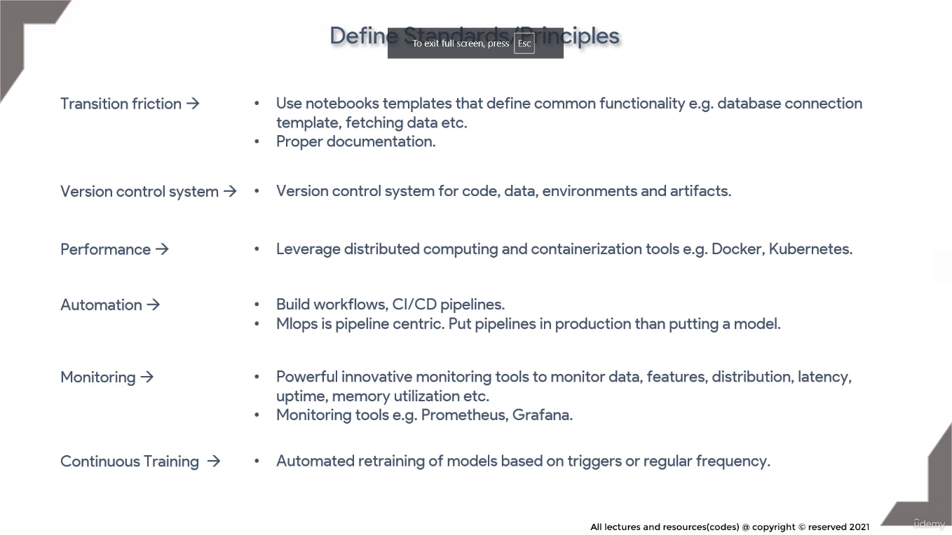

**Standards and Principles** that are crucial in an MLOps (Machine Learning Operations) framework. Here’s a breakdown of the items in the diagram and their explanation:

**1. Transition Friction:**

* **Explanation**: Transition friction refers to the difficulties and inefficiencies in transferring code or models from development (e.g., Jupyter notebooks) into production.
  + **Use Jupyter Notebook templates**: Define standard templates for common tasks (e.g., database connection, data fetching) to make code more consistent and reusable.
  + **Proper documentation**: Ensures smooth handoff between teams (e.g., data scientists and engineers), making it easier for others to understand and deploy models without issues.

**2. Version Control System:**

* **Explanation**: Version control is essential for tracking changes and maintaining consistency across different versions of code, data, and models.
  + **Version control for code, data, environments, and artifacts**: Apply version control not only to the model code but also to datasets, configurations, feature parameters, and dependencies. Tools like **Git**, **DVC**, and **MLflow** help manage these versions effectively.

**3. Performance:**

* **Explanation**: Performance is about ensuring that the model runs efficiently, especially when handling large datasets or operating in real-time systems.
  + **Leverage distributed computing and containerization**: Use tools like **Docker** for containerization and **Kubernetes** for orchestration to ensure the model can be scaled and run on distributed systems, handling large datasets and workloads.

**4. Automation:**

* **Explanation**: Automating the machine learning lifecycle reduces manual intervention, speeds up processes, and ensures models remain current with new data.
  + **Build workflows, CI/CD pipelines**: Set up continuous integration/continuous delivery (CI/CD) pipelines to automate tasks such as testing, training, deployment, and updating models. Tools like **Jenkins**, **GitLab CI**, and **Airflow** are commonly used.
  + **MLOps is pipeline-centric**: Rather than focusing on the model itself, MLOps focuses on creating automated pipelines that manage the entire lifecycle of the model, from development to deployment and monitoring.

**5. Monitoring:**

* **Explanation**: Once models are in production, monitoring their performance, data quality, and infrastructure is crucial for ensuring stability and preventing issues like model drift.
  + **Powerful monitoring tools**: Use tools like **Prometheus** and **Grafana** to monitor model data, feature distributions, prediction latency, memory usage, and uptime. Effective monitoring helps detect problems early, such as data drift or performance degradation.
  + **Monitor data, features, latency, memory utilization**: Keep track of key metrics like the data distribution (to detect **drift**, **WhyLabs**), how the features are being used, the speed of predictions, and the health of the infrastructure (e.g., memory usage).

**6. Continuous Training:**

* **Explanation**: In production environments, models may need to be retrained periodically to stay relevant as new data becomes available.
  + **Automated retraining of models**: Set up triggers or scheduled retraining to automatically refresh models when certain conditions are met (e.g., new data is available, or model performance drops). This ensures models stay accurate over time without manual intervention.
  + **Regular frequency**: Establish a retraining cadence based on business needs or model performance trends.

**Summary of the Key MLOps Standards and Principles:**

* **Transition Friction**: Minimize the complexity of moving models from development to production by using standardized templates and documentation.
* **Version Control**: Manage code, data, and model versions to ensure reproducibility and traceability.
* **Performance**: Use containerization and distributed computing to scale models and optimize performance.
* **Automation**: Build end-to-end CI/CD pipelines that handle the full model lifecycle with minimal manual effort.
* **Monitoring**: Continuously track model performance, resource usage, and data quality to ensure stability.
* **Continuous Training**: Implement automatic retraining mechanisms to keep models up to date and maintain high performance.

These standards and principles help streamline the machine learning lifecycle, ensuring efficient, scalable, and reliable model deployment in production environments.

**Key Components of MLflow**

**MLflow** is an open-source platform designed to manage the complete machine learning (ML) lifecycle, including experimentation, reproducibility, and deployment. It allows data scientists and engineers to **track** and **manage** the development of machine learning models in a structured and efficient way.

Here are the **key components of MLflow** and their purposes:

**1. MLflow Tracking:**

* **Purpose**: To track and log machine learning experiments, including code, parameters, metrics, and artifacts.
* **How It Works**:
  + MLflow allows users to track every run (experiment) of their model training by logging parameters (e.g., learning rate), metrics (e.g., accuracy, loss), and output artifacts (e.g., model binaries, plots).
  + It automatically logs information like the start and end times, the source code used, and any dependencies.
  + You can visualize these experiments through a UI and compare them to understand the best-performing model.
* **Use Cases**:
  + Comparing multiple training runs to determine the best hyperparameter settings.
  + Reproducing experiments by saving all the necessary details of each experiment.

**2. MLflow Projects:**

* **Purpose**: To **package** and organize machine learning code in a reusable and reproducible format.
* **How It Works**:
  + MLflow Projects use a standardized format to encapsulate code, dependencies (e.g., conda.yaml or requirements.txt), and configuration for easy reproducibility.
  + Each project can be defined by a single **MLproject** file, which includes the environment, dependencies, and command to execute the code.
  + Projects can be run locally or remotely (e.g., on a cloud instance or different machine), making it easier to share and reproduce experiments across different environments.
* **Use Cases**:
  + Sharing ML projects across teams or with other collaborators for consistent and reproducible results.
  + Running an experiment on different machines with guaranteed consistency of the environment and dependencies.

**3. MLflow Models:**

* **Purpose**: To manage and serve machine learning models in multiple formats.
* **How It Works**:
  + MLflow Models is a convention for packaging ML models in a standardized format for deployment and inference.
  + A model saved with MLflow can be deployed in a variety of environments, including REST APIs, batch jobs, or real-time inference services.
  + MLflow provides built-in support for many popular libraries such as **Scikit-learn**, **TensorFlow**, **PyTorch**, **XGBoost**, and more.
  + Models are saved in a universal format that allows them to be used with different deployment tools such as **Docker**, **Kubernetes**, **Azure ML**, and **AWS SageMaker**.
* **Use Cases**:
  + Deploying models to different platforms without needing to refactor the code for each platform.
  + Versioning models to allow easy rollback to previous versions in case a deployment fails.

**4. MLflow Model Registry:**

* **Purpose**: To centralize and manage the lifecycle of machine learning models, including versioning, staging, and production deployment.
* **How It Works**:
  + The model registry is a repository for ML models. It provides APIs and a UI for registering models, promoting them to different stages (e.g., **staging**, **production**), and managing model versions.
  + It allows tracking of which version of a model is deployed in production, and it also supports annotations, descriptions, and transitions (e.g., from **staging** to **production**).
  + It includes features for managing metadata such as model signatures, which describe the input/output schema for the model.
* **Use Cases**:
  + Version control for machine learning models, allowing rollback to previous versions if necessary.
  + Managing model lifecycle, including transitioning models between development, testing, and production environments.

**5. MLflow Serving:**

* **Purpose**: To serve models via a **REST API** for real-time or batch inference.
* **How It Works**:
  + MLflow’s serving component allows you to deploy models as REST APIs easily. Once a model is registered or logged with MLflow, you can serve it with a single command.
  + It supports multiple backends, such as **local server**, **Docker**, and cloud platforms, and provides a consistent interface for interacting with models across different deployment environments.
* **Use Cases**:
  + Deploying models as microservices to handle real-time predictions.
  + Providing batch inference capabilities using the same model.

**6. MLflow Artifacts:**

* **Purpose**: To store and manage files (artifacts) related to the training and evaluation of machine learning models.
* **How It Works**:
  + Artifacts in MLflow can be any type of file generated during experiments, such as datasets, models, logs, or evaluation metrics.
  + These artifacts are tracked and stored as part of the model training run, and MLflow provides a mechanism for retrieving them at any point.
  + Artifacts can be stored locally, on distributed file systems, or on cloud storage systems such as AWS S3, Azure Blob Storage, and Google Cloud Storage.
* **Use Cases**:
  + Saving important artifacts like training logs, metrics, or visualizations that can be referenced later.
  + Storing evaluation reports that can be used to understand the model's performance over time.

**Purpose of MLflow in the ML Lifecycle:**

MLflow helps manage the entire machine learning lifecycle by addressing several key areas:

1. **Experiment Tracking and Reproducibility**: MLflow makes it easy to track every aspect of the machine learning lifecycle, including code, data, metrics, parameters, and artifacts, ensuring that every run is reproducible.
2. **Model Packaging and Sharing**: By packaging machine learning code and models in a standard format, MLflow ensures that models can be shared across different teams and environments without compatibility issues.
3. **Deployment and Serving**: MLflow simplifies the process of deploying models to production. Its standardized model format allows for easy deployment to different environments, and the Model Registry helps manage the lifecycle of models.
4. **Monitoring and Versioning**: MLflow offers model versioning and lifecycle management, allowing models to be updated, promoted, or rolled back across different stages (development, staging, production). It also provides visibility into which version of the model is running in production.
5. **Automation**: Through integration with CI/CD pipelines, MLflow facilitates automating repetitive tasks such as model retraining, evaluation, and deployment.

**Conclusion:**

MLflow provides a comprehensive framework for managing machine learning models across their entire lifecycle. Its components support experimentation, reproducibility, deployment, and model versioning, which are essential for managing machine learning in production.